Action Declaration for Peace and Human Rights Name( )
～Tell the world what you can do for peace and human rights.
Let‘s share our message on Instagram, You Tube, X, Line and school website.～
〇Writing Structure Notes
Key Ideas/ My First Idea

Keywords/ Important Words


Kaisei. J.H. 2013
11月14日

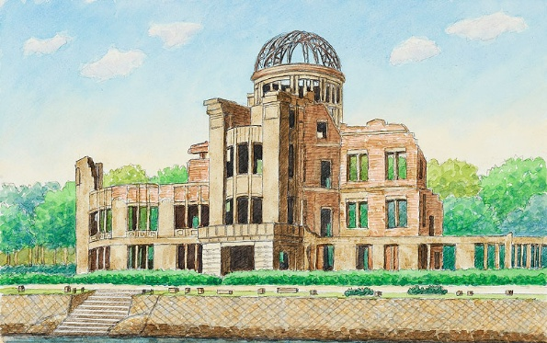



♡201３ ４０１

Kaisei. J.H. 2013
Advice or Comments from Friends

Advice or Comments from Friends

